**© SPS Vietnam**

**DISCO DDS System**

**System Design Document**

**Document Ref. IT201-ARC**

**Version: 1.3**

**Release 4**

Author: {name} – SPS Vietnam

Last update: Wednesday, 16 Nov 2016

**Revision History**

|  |  |  |  |
| --- | --- | --- | --- |
| **Version** | **Date** | **Author** | **Summary of Changes** |
| X0.1 | 15.07.2016 | Binh Le | First draft |
| 1.0 |  | Huy Truong | Approve first release |
| 1.1 | 18.08.2016 | Binh Le | Update overview, dpm-general, ampplus, asdp, gAlias and zubofi |
| 1.2 | 19.08.2016 | Binh Le | Add new DPM activity |
| 1.3 | 16.11.2016 | Binh Le | Update class-diagram, database design & Business Core Overview  Add Infrastructure design |

**Distribution**

|  |  |
| --- | --- |
| **Name** | **Title** |
| Thuat Bui | Project Manager |
| Huy Truong | Software Manager |
|  |  |
|  |  |
|  |  |
|  |  |

**Approval**

|  |  |  |  |
| --- | --- | --- | --- |
| **Name** | **Position** | **Signature** | **Date** |
| Thuat Bui | CTO |  |  |

**Contents**

1 Introduction 6

1.1 Purpose 6

1.2 Scope 6

1.3 Definitions, Acronyms, and Abbreviations 6

1.4 Reference documents 6

1.4.1 Master list 6

1.4.2 References document 6

1.4.3 References external source 7

2 System Design 8

2.1 Technical Solutions: 8

2.2 Master data importer 8

2.2.1 Overview 8

2.2.2 Activity 10

2.2.2.1 AMPplus 10

2.2.2.2 ASDP 10

2.2.2.3 gAlias 12

2.2.2.4 Zubofi 13

2.2.3 Class Diagrams 14

2.3 DDS Core Business 15

2.3.1 Overview 15

2.3.2 Activity Diagrams 17

2.3.3 Class Diagrams 19

2.3.3.1 Parcel (PDS) 20

2.3.3.2 Receiver (DPM) 21

2.3.3.3 Padasa-Barcode 21

2.3.3.4 Padasa-Matchmaker 22

2.3.3.5 VAE 23

2.3.3.6 VAM 24

2.4 DMC Processing 25

2.4.1 Activity 25

2.4.2 Class diagrams 26

3 Database Design 27

3.1 Master Data 27

3.1.1 AMPplus 27

3.1.2 ASDP 28

3.1.3 Zubofi 28

3.1.4 Batch Job 30

3.1.5 Combination 31

3.2 DDS 32

3.2.1 Parcel (PDS) 32

3.2.2 Receiver(EAI or DPM) 33

4 Infrastructure Design 33

# Introduction

## Purpose

This document provides an architectural overview of DISCO R2 system

## Scope

DISCO R2 includes DDS core business, Master Data, Logging System, DMC & Web-Report

## Definitions, Acronyms, and Abbreviations

|  |  |  |
| --- | --- | --- |
| **#** | **Synonyms/Abbreviations** | **Term** |
| 1 | SMT | **S**ystem **M**anagement **T**ool |
| 2 | ELK | **E**lastic **L**ogstash **K**ibana |
| 3 | DMC | **D**ata **M**atrix **C**ode |
| 4 | DPM | **D**aten**p**rüfungs**m**odul |
| 5 | VAE | **V**olle **A**dress**e**rfassung |
| 6 | VAM | **V**olle **A**ddress **M**anager |

## Reference documents



### Master list

|  |  |  |
| --- | --- | --- |
| **#** | **Document name** | **Description** |
| 1 | SPS_DISCO_R2_Concept_Design | Technical concept design of DISCO R2 system |
| 2 | SPS_DSCO_R2_WBS_v1.0 | Work Breakdown Structure for cost estimation |
| 3 | SPS_ DSCO_R2_Diagram | Visio file contains all diagrams, workflows related to the project |

### References document

|  |  |  |
| --- | --- | --- |
| **#** | **Document name** | **Description** |
| 1 | SA_ABA_Abloesung_VG.docx v0.108 | Requirements & Use Cases specification of new DISCO R2 system |
| 2 | SY_Schnittstelle_DPM_DISCO_X0101_english.docx | English translation |
| 3 | [English_V2]_PDS_ParcelInfoService_V0224 | English translation from original version PDS_ParcelInfoService_V0224 – PDS web service specification |
| 4 | Mengen_20150126.xlsx | Reference for amount of data will be processed through the DISCO R2 on each steps |
| 5 | wsdl_jce_jcdBCParcelData-1525627507.wsdl | Data structure of DMC Barcode to PADASA |
| 6 | VAE_Systemanforderungen_Vam_V01.14.docx | Data structure of DISCO R2 to VAM |

### References external source

|  |  |  |
| --- | --- | --- |
| **#** | **Document name** | **Description** |
| 1 | <https://en.wikipedia.org/wiki/Responsibility_assignment_matrix> | Reference for RACI matrix |
| 2 |  |  |
| 3 |  |  |
| 4 |  |  |
| 5 |  |  |
|  |  |  |

# System Design

## Technical Solutions:

|  |  |  |
| --- | --- | --- |
| **#** | **Technical** | **Description** |
| 1 | Java 8 | Runtime Environment |
| 2 | Spring-Batch | Batch application framework |
| 3 | Spring-Boot | Enterprise development framework |
| 4 | Spring-Security | Authentication and authorization framework |
| 5 | Spring-MVC | Web development framework |
| 6 | Spring-Cloud-Config | Support externalized configuration in distributed system |
| 7 | AngularJS | JavaScript-based open-source client |
| 8 | Highchart | Interactive JavaScript charts for your web pages |
| 9 | Infinispan | Caching solution |
| 10 | stAX | API for XML processing is designed for parsing XML |
| 11 | ELK | Logging System |
| 12 | ClearImage | DMC engine |

## Master data importer

### Overview

Here is an overview of Master Data Importer system.

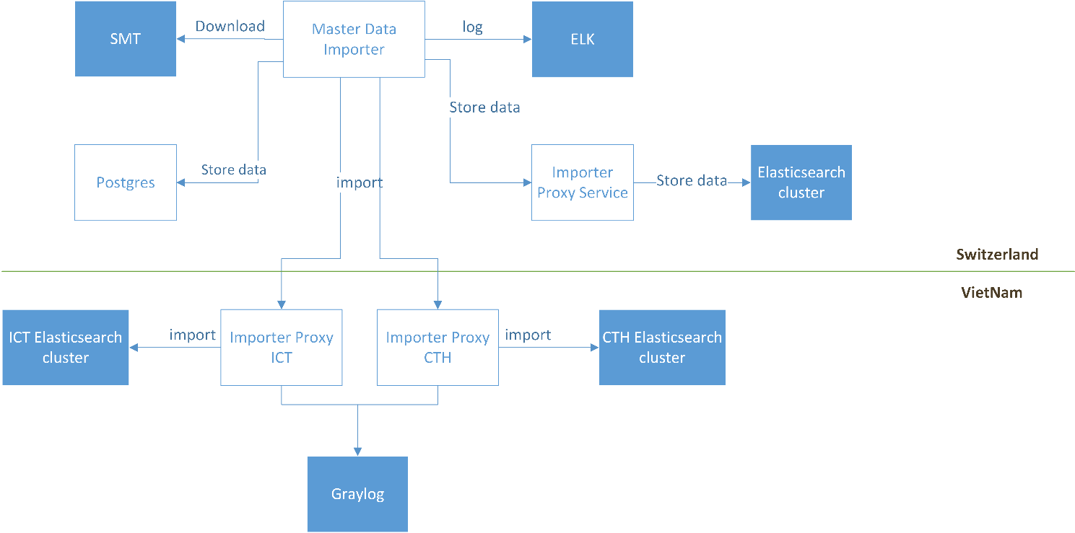

### Activity

#### AMPplus

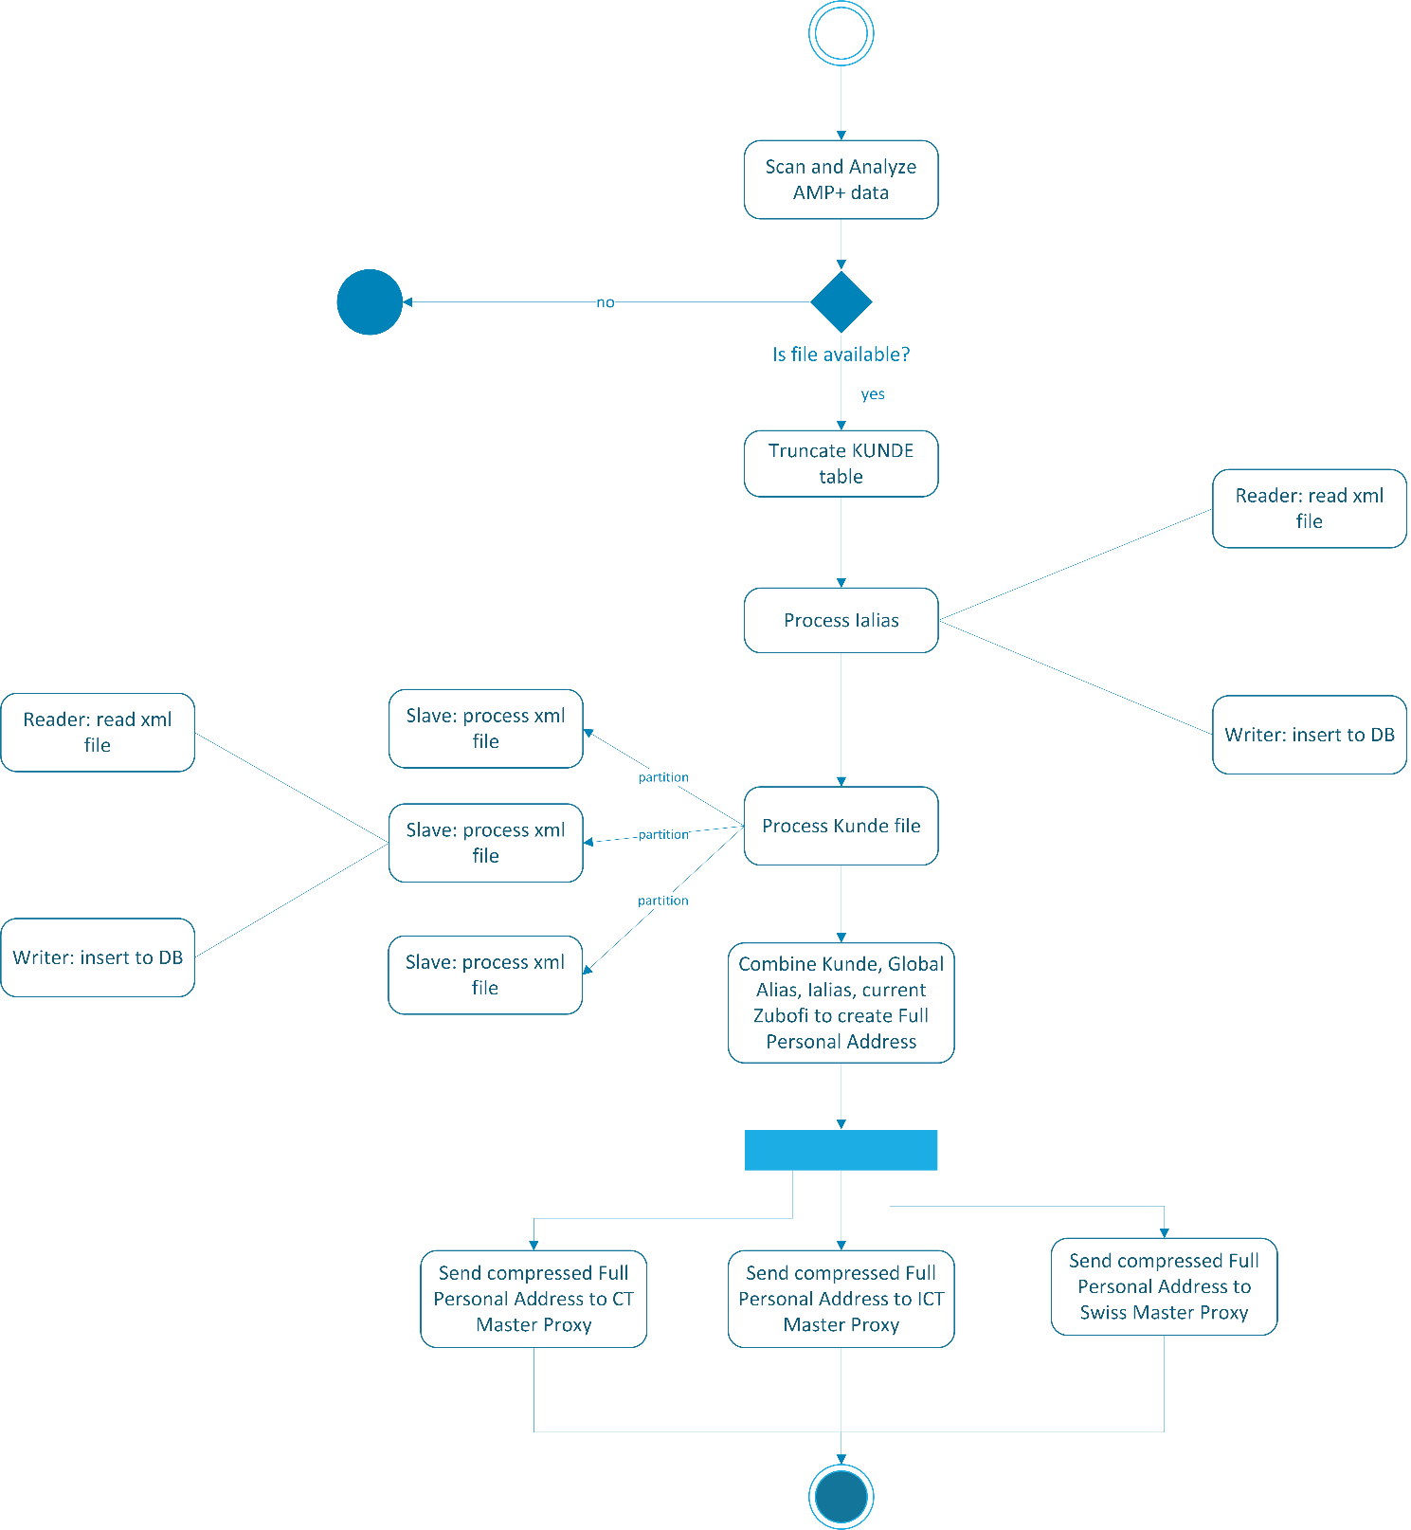

#### ASDP

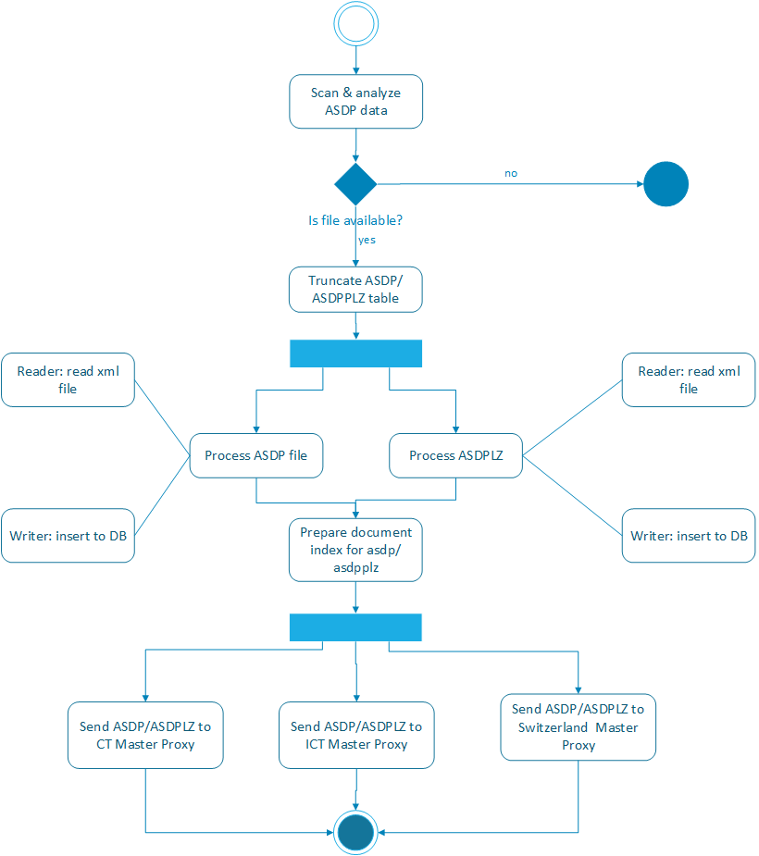

#### gAlias

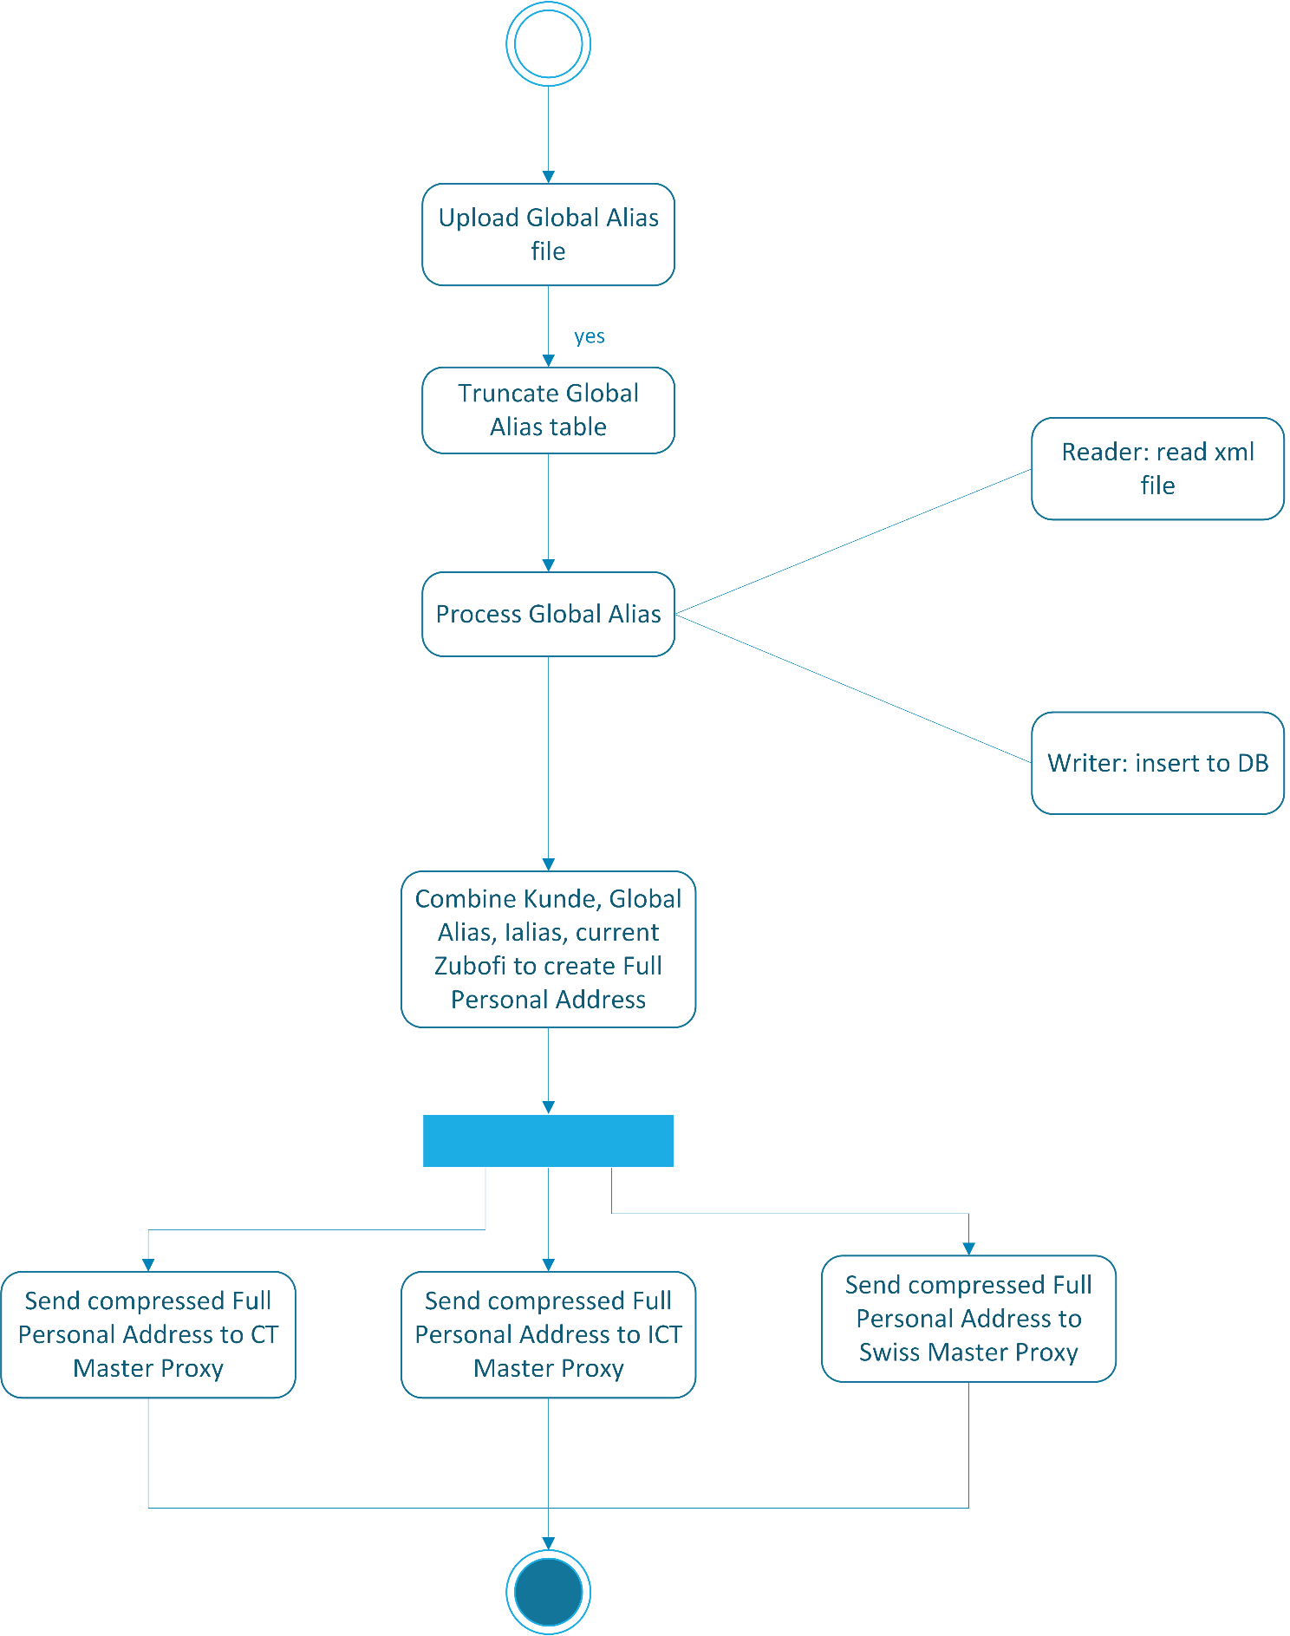

#### Zubofi

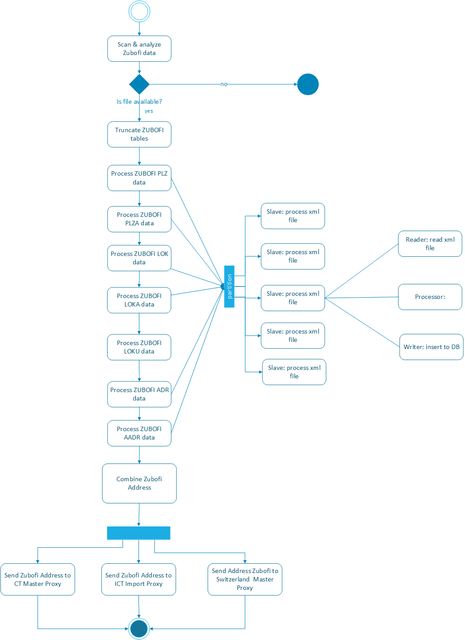

### Class Diagrams

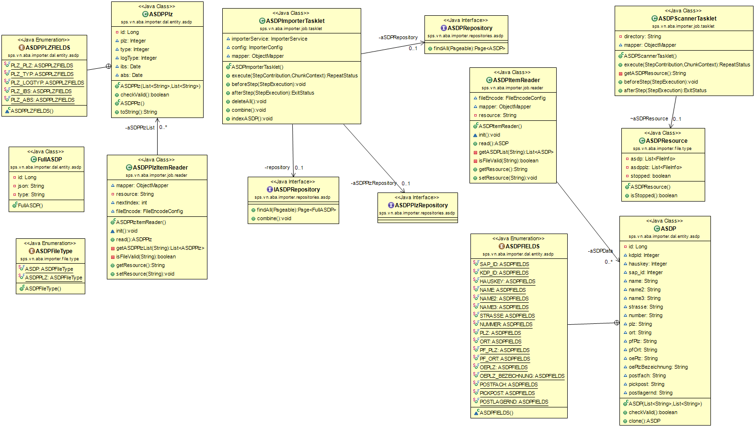

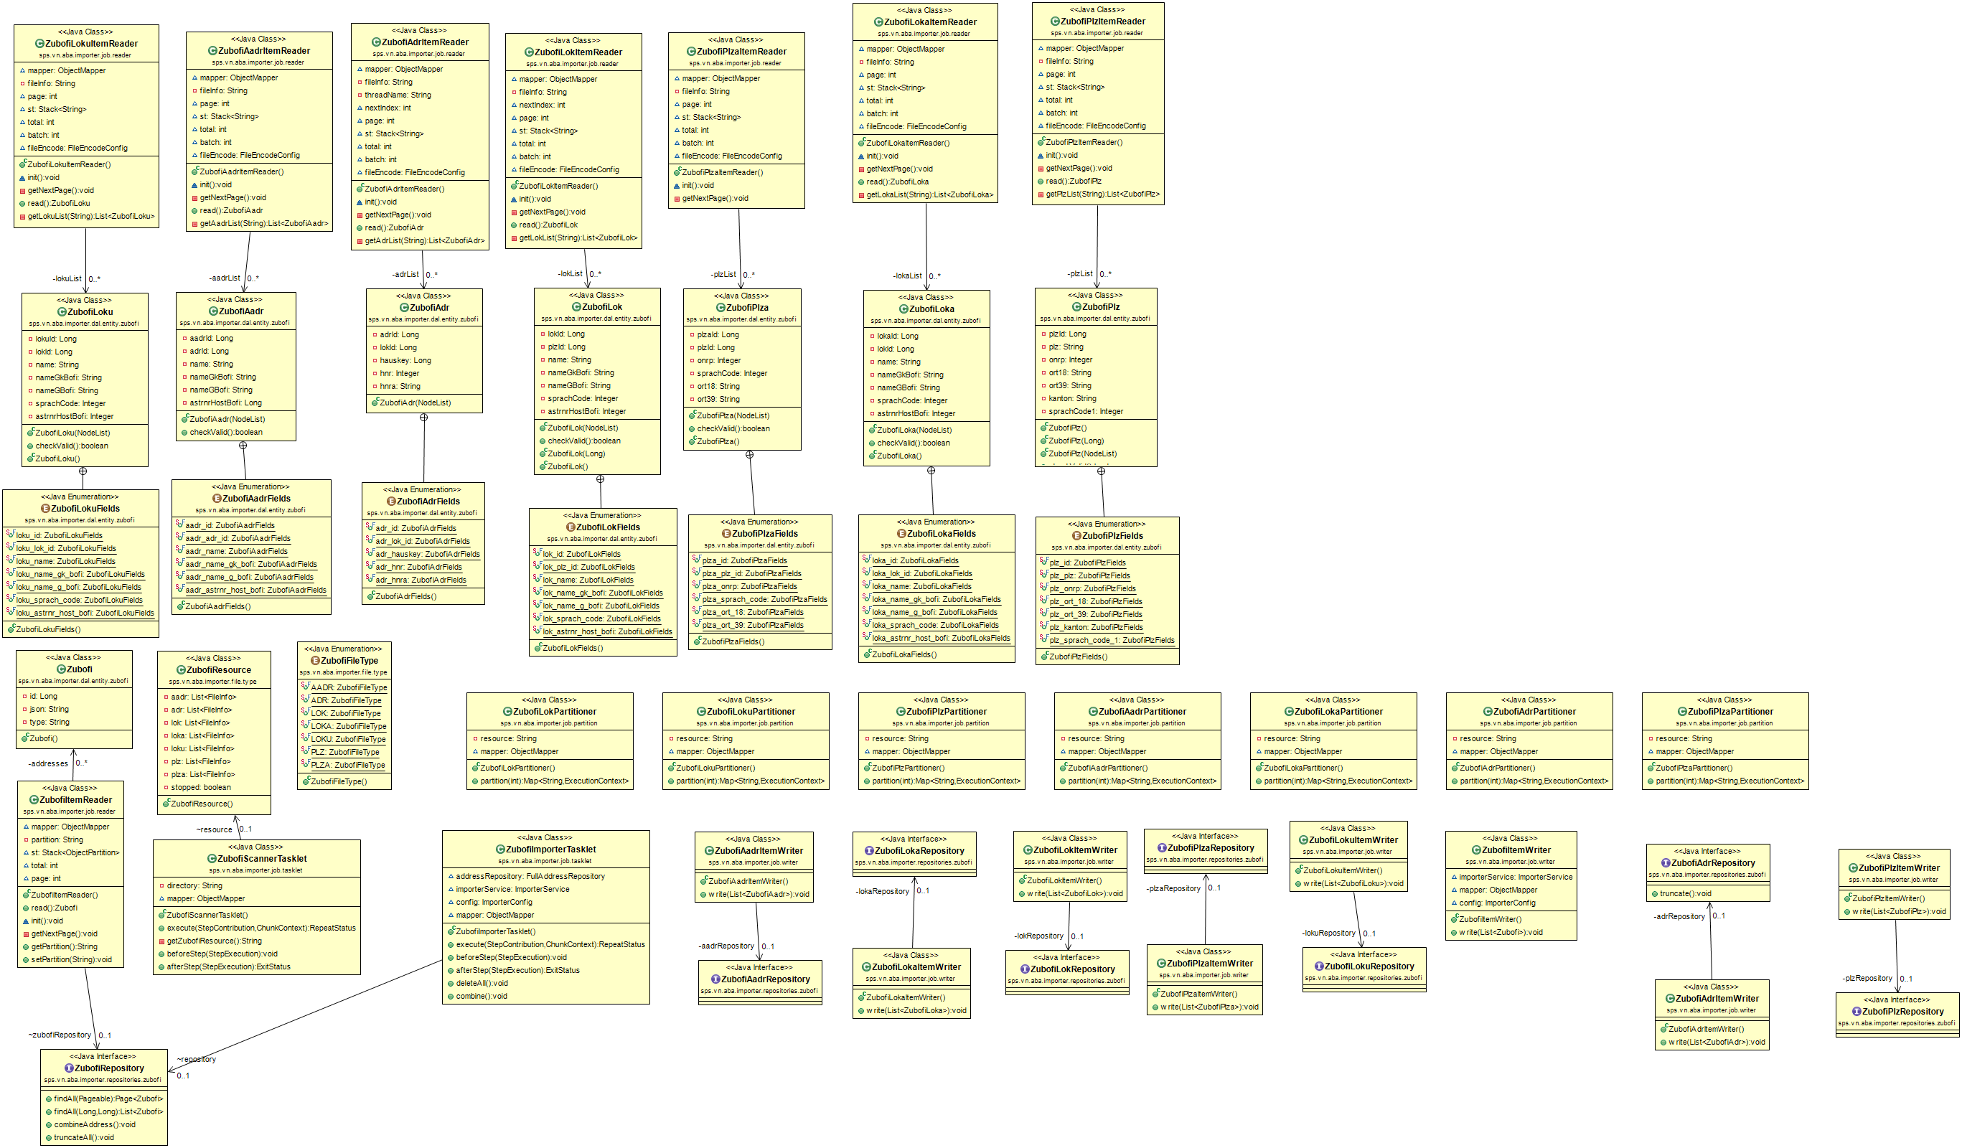

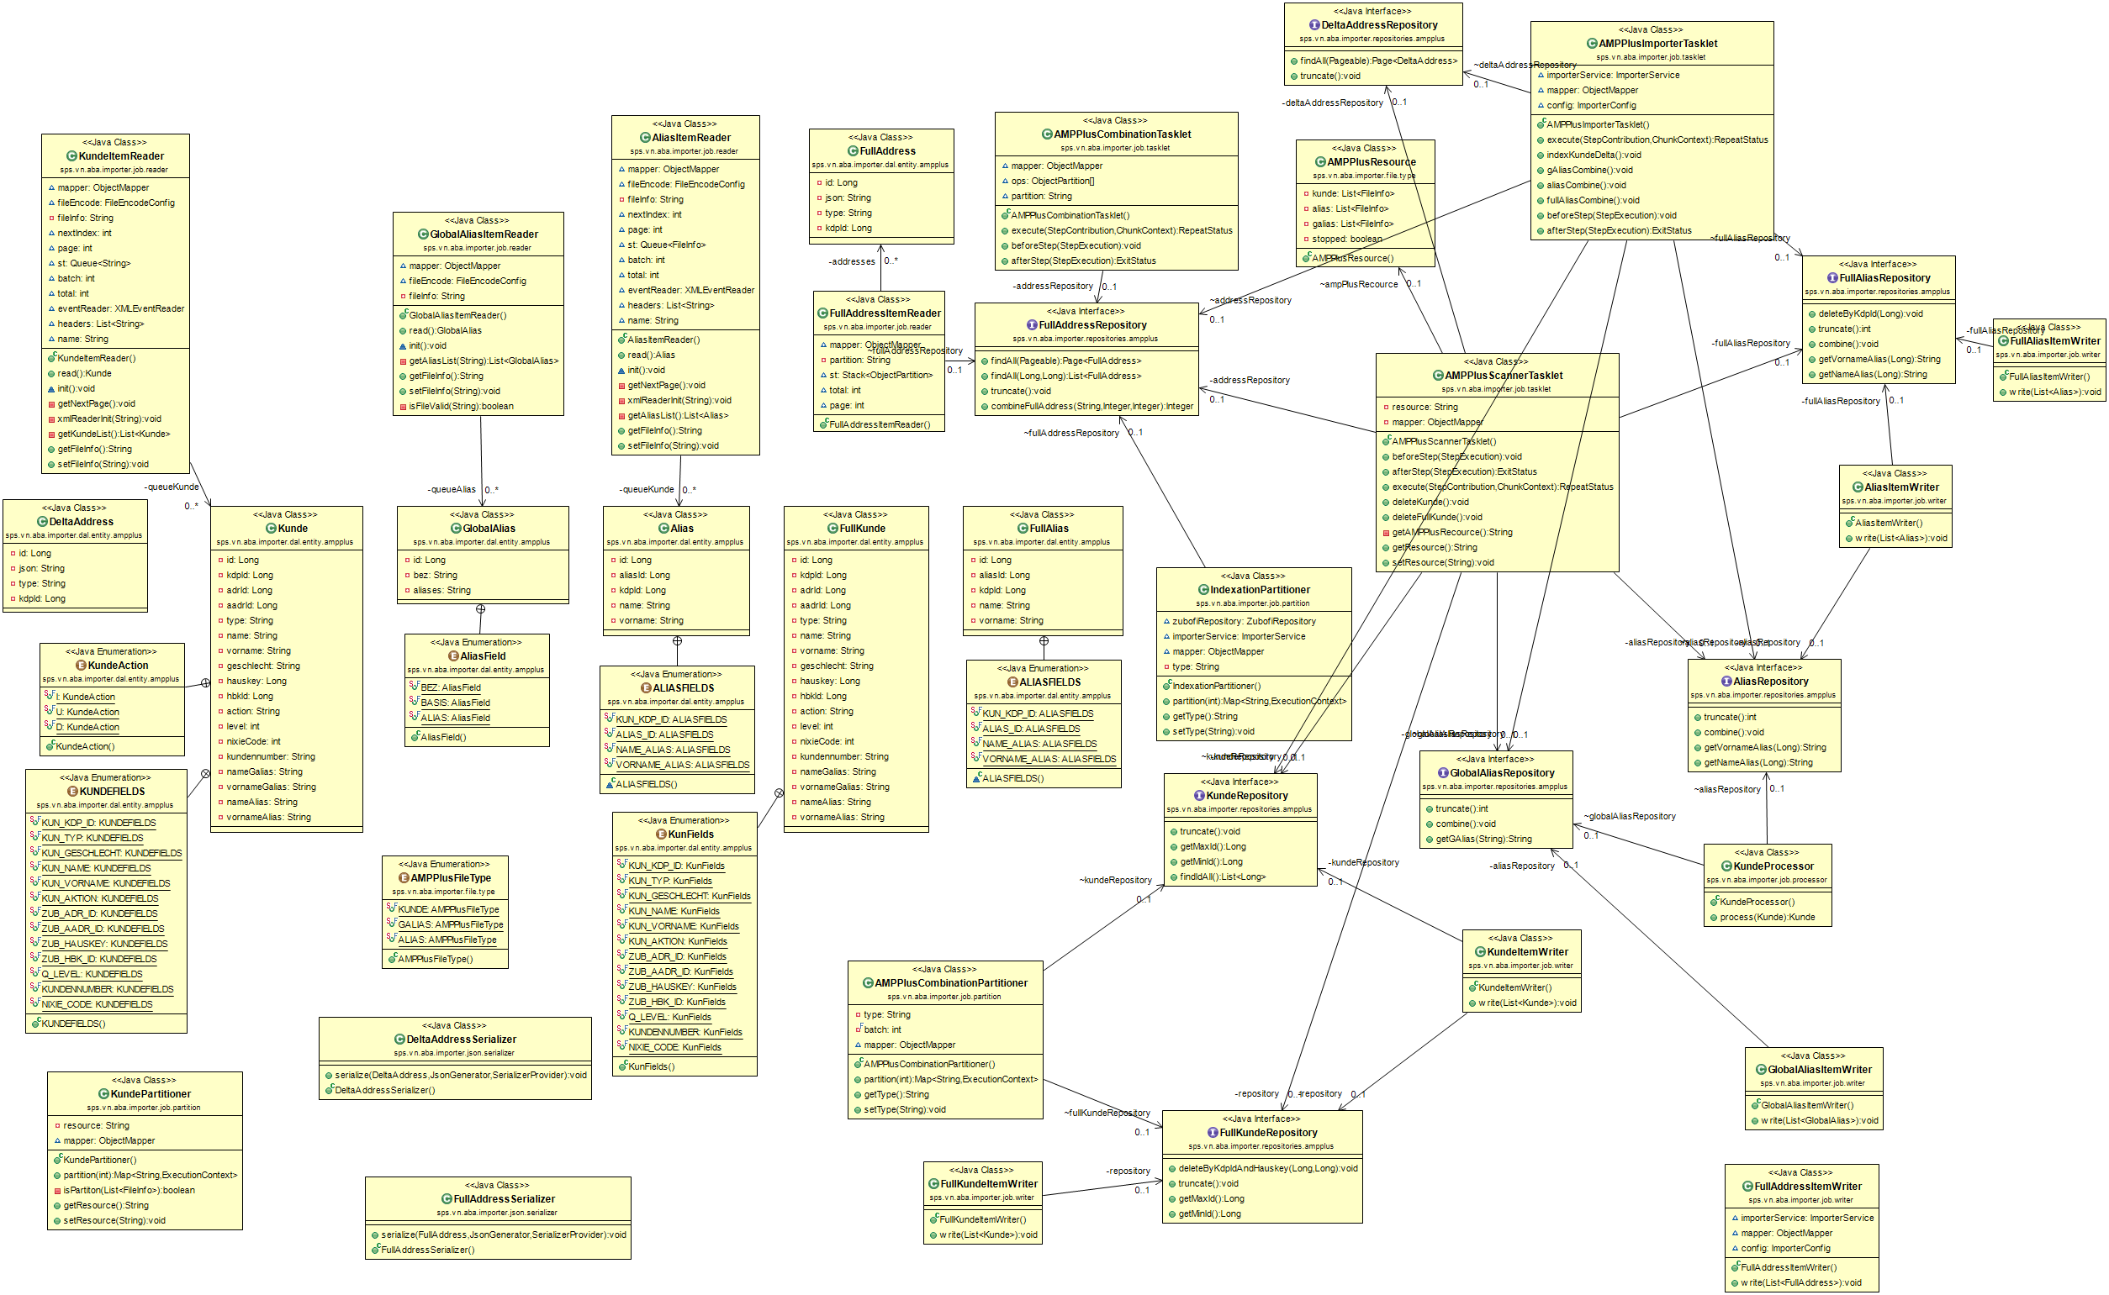

## DDS Core Business



### Overview

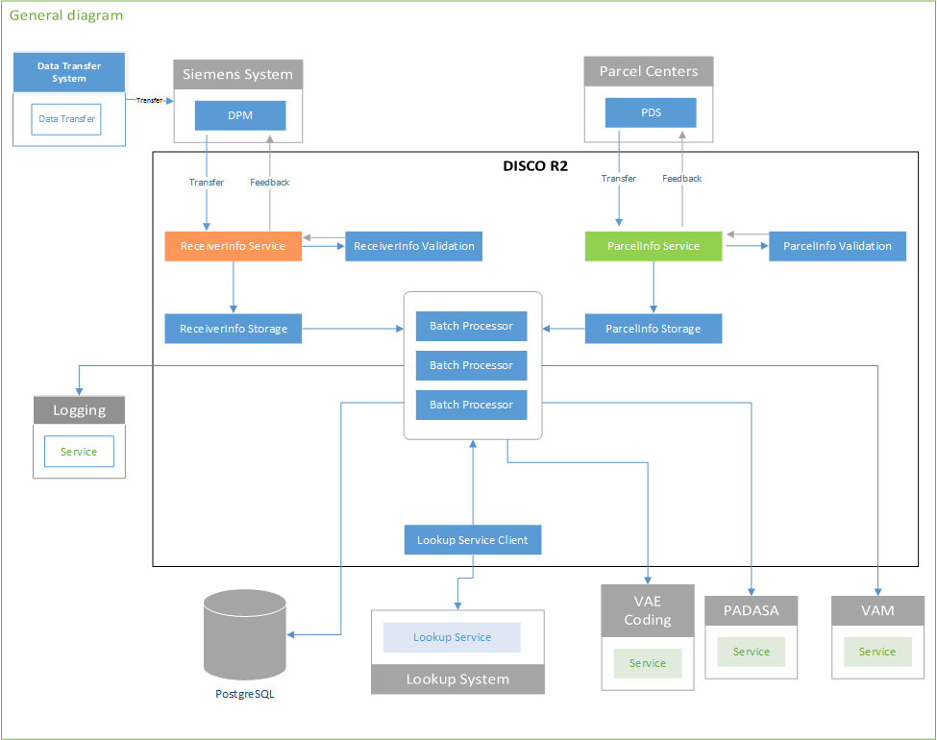

### Activity Diagrams

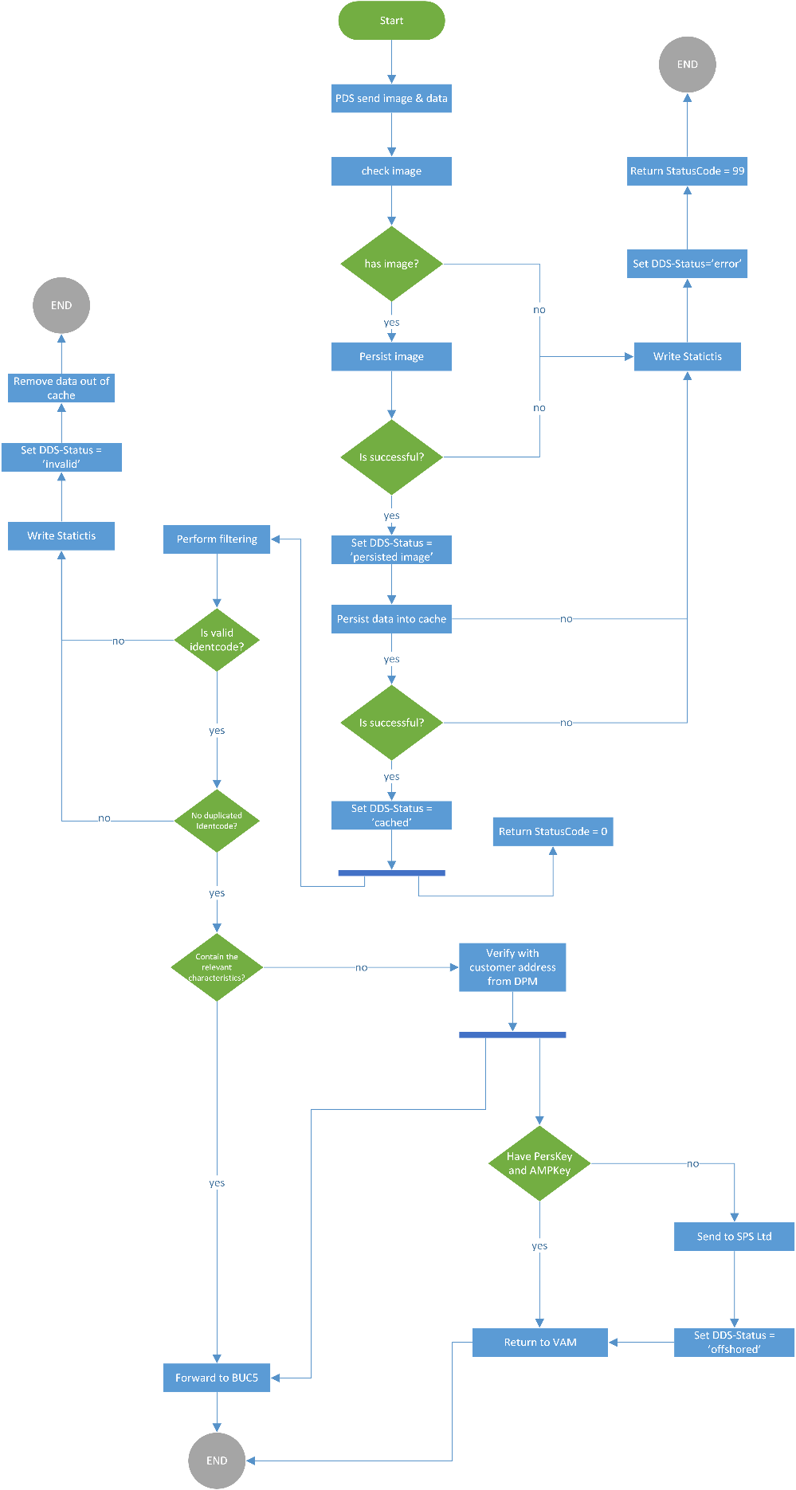

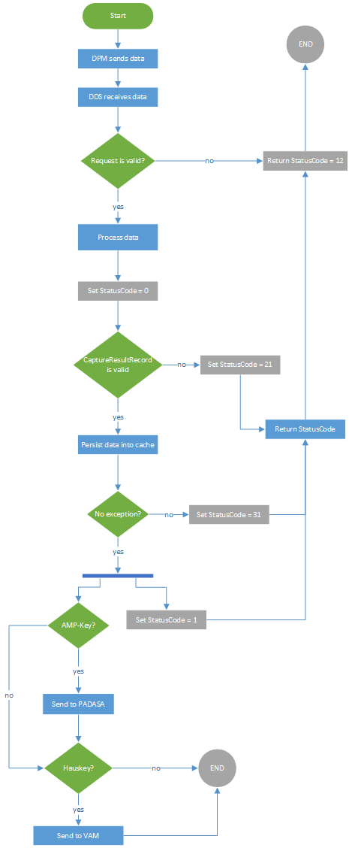

### Class Diagrams

#### Parcel (PDS)

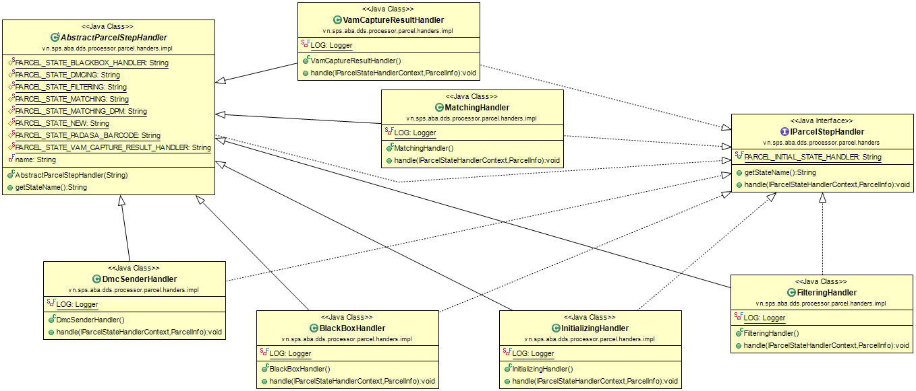

#### Receiver (DPM)

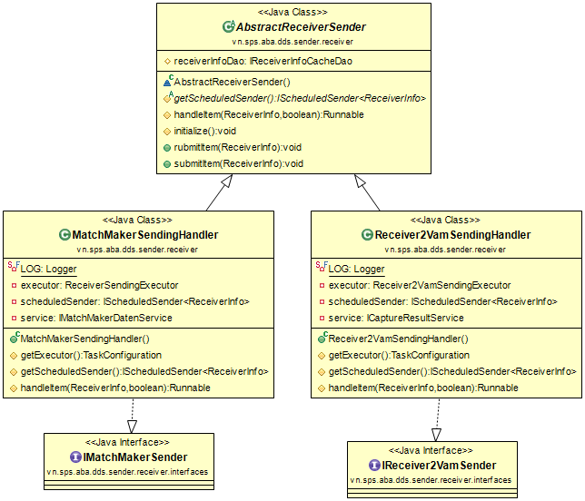

#### Padasa-Barcode

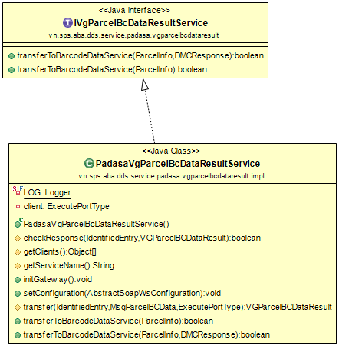

#### Padasa-Matchmaker

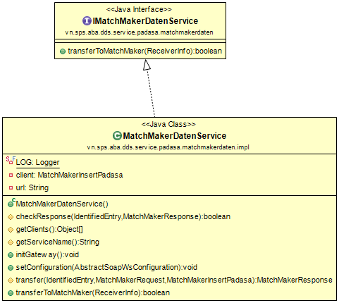

#### VAE

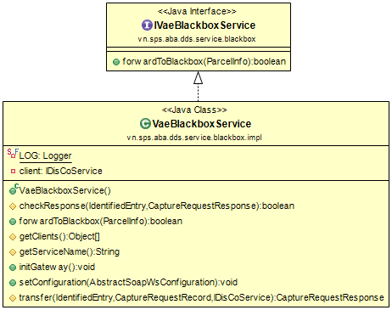

#### VAM

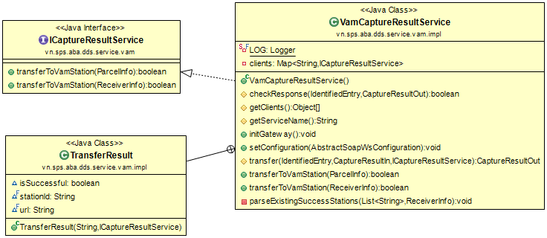

## DMC Processing



### Activity

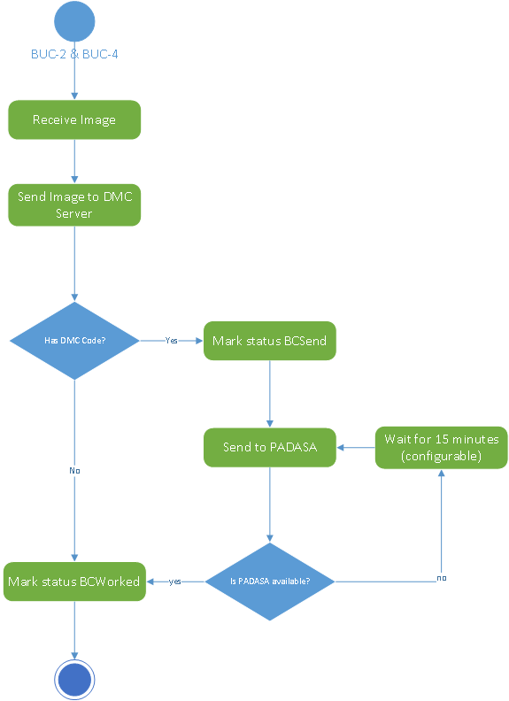

### Class diagrams

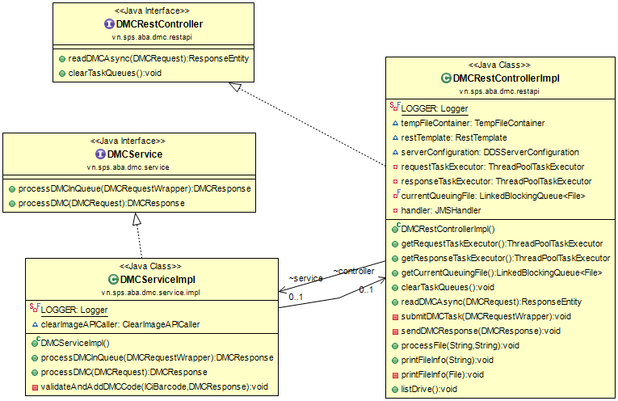

# Database Design

## Master Data

### AMPplus

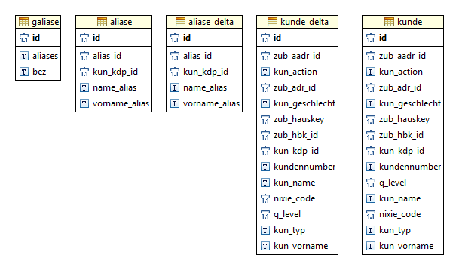

|  |  |
| --- | --- |
| **No** | **Foreign key constraint** |
| 1 | aliase.kun_kdp_id = kunde.kun_kdp_id |
| 2 | aliase_delta.kun_kdp_id = kunde_delta.kun_kdp_id |

### ASDP

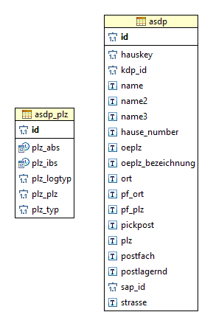

### Zubofi

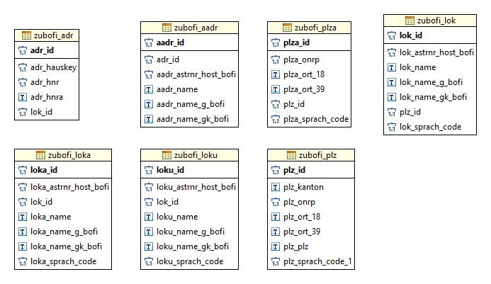

|  |  |
| --- | --- |
| **No** | **Foreign key constraint** |
| 1 | zubofi_aadr.adr_id = zubofi_aadr.adr_id |
| 2 | zubofi_aadr.lok_id = zubofi_lok.lok_id |
| 3 | zubofi_loka.lok_id = zubofi_lok.lok_id |
| 4 | zubofi_loku.lok_id = zubofi_lok.lok_id |
| 5 | zubofi_plz.plz_id = zubofi_lok.plz_id |
| 6 | zubofi_plz.plz_id = zubofi_plza.plz_id |

### Batch Job

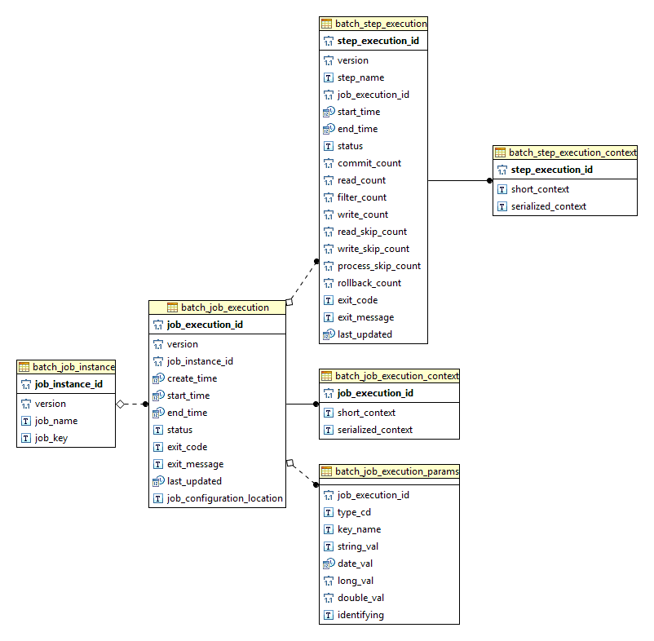

### Combination

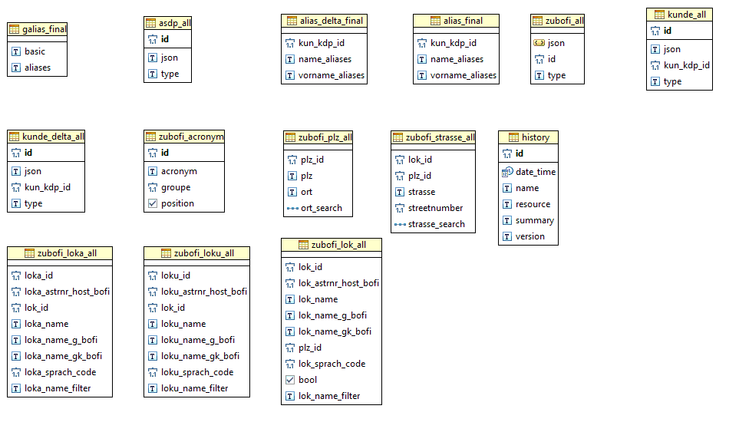

## DDS

### Parcel (PDS)

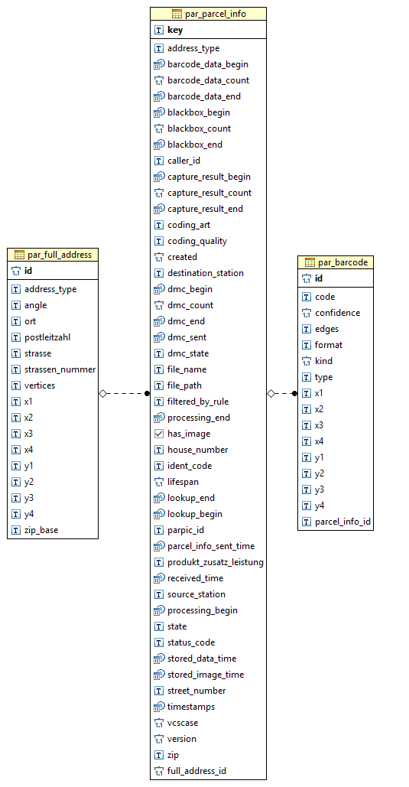

### Receiver(EAI or DPM)

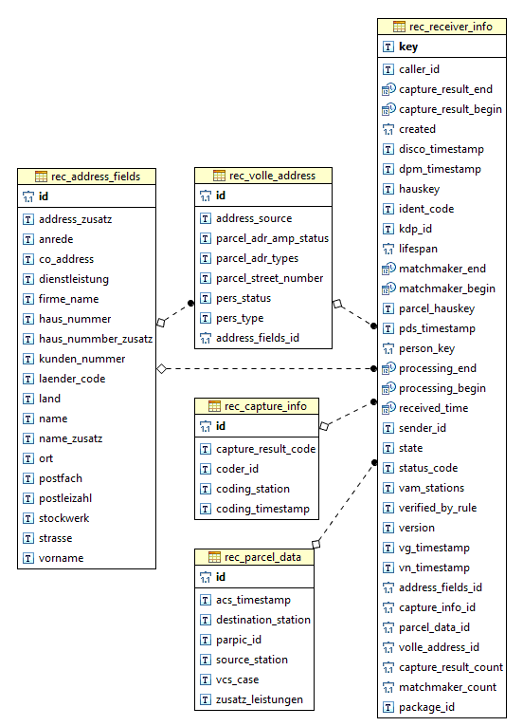

# Infrastructure Design

Reference to :

<https://tools.spsdscloud.com/confluence/display/VNABA/ABA+System>